**AE 342 Final Project**

**Michael Bell**

**5/7/2015**

**Introduction:**

The purpose of this final project was to fully simulate the power delivery system and engine components of a real life tractor. This simulation must be able to replicate a fully functioning transmission and gear control system. This transmission must work automatically without any input needed from the operator. The transmission is also required to protect the engine from overloading. The tractor must also must accurately represent the energy flow through the engine, using various thermodynamic properties and fundamentals of engine power systems. The engine should be controlled by a governor system to calculate the amount of fuel required. The model must also incorporate a system to calculate traction forces as well as the dynamic weight transfer as the draft is increased. The draft control system will be supplied by the instructor, but it is required to be incorporated into the model.

The program that was used to model this was Simulink. To keep the model as accurate as possible I attempted to replicate a John Deere model 8420 tractor. Even though I was working without a group, I wanted to not oversimplify my model, and the following paragraphs will explain where, what, and why I simplified certain aspects of the model. I will also cover any assumptions that I made throughout my development and testing of the model.

**Literature Review:**

Tractors have become an integral part of agriculture, and although the complexity and efficiency has improved throughout the years, the basic concepts have stayed relatively constant. The key idea that has driven the development of tractors is being able to do more work faster.

The method of creating power has changed significantly throughout the modern farming years. Diesel tractors have become the standard in today’s tractors, but this was not always the case. The earliest tractors were known as traction engines, and were powered by steam engines. These early tractors were prevalent from the 1860’s into the early 1900’s. These steam powered tractors were not extremely efficient, and were primarily only used for plowing. Although the steam powered tractors were not the perfect solution or economical for all farmers, they were the start of the engine powered farming era.

John Froelich is credited with creating and building the first gasoline engine tractor. He created this in 1892 in Clayton County Iowa. Although it was not successful, it marks the start of the internal combustion engine tractor period. Throughout the next 60 years gasoline powered tractors became prevalent in agriculture. One of the more notable early tractor models was the Fordson, created and produced by Henry Ford. This was mass produced in 1917, and was very popular. This tractor used the strength of the engine block as a frame, saving weight and improving efficiency. The next great development was invented by Harry Ferguson in 1926. This was the creation of the three-point hitch. This went on to become the standard for hitch styles.

Diesel engines gained popularity starting in the 1960’s. Today they are the most common type of tractor by far, and this is also the engine type that is in the Deere 8420 that I modeled my system after.

**Summary of Approach:**

For the bulk of this project I tried to keep the truly relevant systems detailed. The systems and areas that truly impact the function of the overall model I attempted to keep as detailed as possible. Due to the complex nature of the model when looked at as a whole, I attempted to create each subsystem piece by piece. This allowed me to create and test each system individually, as well as save time on troubleshooting. When testing these pieces I often used constant blocks, and then switched these blocks out as the model gained complexity. Because each system depends on one another to run properly this was required.

The creation of the engine model was tricky due to the lack of readily available information about my chosen tractor. The engine in a Deere 8420 tractor is a PowerTech 8.1L diesel engine. The specific engine details that I required were not available explicitly on the internet. There was not an engine performance map or fuel consumption data available for this engine in a tractor configuration. I did find the manufacturer’s engine performance data for this same engine in a marine configuration, however. This configuration had a stated output of a slightly lower torque rating. I justified that the higher accuracy of this data would be better than having my tractor model have the rated torque that the real life tractor has. This data was far better for building a system with however as I was able to build an equation for the rate of fuel consumption based upon engine load and speed on empirical data. Within my engine subsystem I fully modeled the thermodynamics happening within the engine. This would have been one area that I could have easily simplified my model by not completing. The only output from this that affects the rest of the model is the thermal efficiency which from my testing did not change by a large margin throughout the different phases of loading. I thought it was important to model this system as it is the basis around which everything else happens. Without the combustion process there would not be a tractor period.

The weight transfer and traction sections I was forced to simplify due to lack of time. The weight transfer system I simplified to make the assumption that the ground is level, and I set the system up so that the only implement to be used was the towed implement. By making these simplifications I was able to produce a high quality working model. Given that I was working by myself on this project I thought that this was a reasonable simplification. My main focus was to get the two subsystems finished so that I could ensure that the model as a whole was working.

For the transmission system I decided to replicate the 16 speed transmission that the 8420 utilizes. In order to create the gear ratios for each specific gear (this information was not available), I utilized information from the John Deere owner’s manual for this tractor. This manual provided a max speed for each gear, as well as the engine RPM that this speed was at. Utilizing the standard tire dimensions, I worked backward from the ground speed to the axle rotational speed, and with the axle speed was then able to calculate the reduction that the transmission provided. I also built into the transmission the ability to set the desired ground speed, and it will pick the correct max RPM within each gear to match this speed. An alternative to this method of using discrete gears would have been to model a continuously variable transmission. I could have used the same gear ratios that I calculated previously to create an equation for what the reduction should be to keep the engine at an ideal rpm speed.

**In-Depth System Analysis:**

***Engine and Governor:***

The engine system starts with the governor subsystem. The governor receives the actual engine speed from the engine system, and the engine set speed from the transmission. It uses the empirically developed mass of fuel input equation (which is a function of the engine set speed) to determine the mass of fuel being added if under the engine set speed. If the engine is over the engine set speed then the amount of fuel being supplied is reduced.

After the governor the main engine process takes place. The fuel equivalent power is calculated, and then this is used to determine the indicated engine power. It should be noted that the indicated thermal efficiency is calculated from the thermodynamic subsystem and used in the indicated power equation. In order to find the brake power, the friction power is first calculated. This is an empirically determined equation that is based upon the actual engine speed. The brake power is converted into brake torque, and then the difference of the brake torque and engine load torque are taken. This is integrated to get the angular velocity, which is converted to engine RPM’s. The engine RPM’s are then output to the other systems for further calculations.

***Transmission:***

I modeled my transmission on the 16 speed 8420 transmission. I used gear ranges and ratios based closely upon the actual transmission from the tractor (discussed in section on my approach). This subsystem model starts with inputs from the actual engine speed (from engine) and axle torque (from traction). The engine speed is converted into axle speed by dividing the engine speed by the selected gear ratio. This is then output to the traction subsystem. The engine set speed (determined via desired ground speed and gear ratio) is based upon whatever is set to be the desired speed. This is being input via a constant block. The system checks to make sure the set speed will not make the velocity of the tractor faster than what the operator has input. If the set speed were to be higher, the system will recalculate the set speed to coincide with the operators speed. By setting up this system this way, the computer will pick what the optimal engine rpm is for the gear it currently is according to the desired ground speed.

The second major part of this system is calculating the engine load torque, and selecting the correct gear. I created a logic system that determines whether or not it makes sense to lower or raise gears. For example, if the engine RPM’s decrease below 1200, then the system is instructed to downshift. Also if the load torque becomes higher than the peak engine load torque (or within 25% of this peak) the system will also downshift. Additionally, this system looks at what the hypothetical next gear would look like. If the next gear would produce an engine load torque of less than 25% of peak torque, AND the engine set speed (of the higher gear) is above 1200 then the system will automatically shift to a higher gear. If neither of these two situations is applicable then the system will maintain the current gear.

***Weight Transfer and Traction:***

The weight transfer subsystem receives the current draft force and vertical position of the force (from the draft control system) and calculates the dynamic reaction forces for the front and rear wheels. This system is fairly simple because for the sake of time the system assumes horizontal operation and that the implement will be towed. This system outputs the dynamic reaction forces to the traction control system.

The traction subsystem receives the reaction forces, axle speed, and horizontal draft force. It calculates the towed forces for each tire, and then calculates the gross tractive force required for one tire. The axle torque is then found by multiplying the gross tractive force for the rear axle times the radius of the rear rim and tire. The slip is calculated using radial ply Brixius Equations. This slip is then used to determine the actual ground speed of the tractor.

**Results and Final Conclusions:**

For this section on my results and especially for the included graphs, the following should be noted. My model uses initial conditions and should not be expected to produce stable results until the system is able to stabilize (usually around a time of 100). The draft control module is set to start in at 500 seconds. This is based upon a 24 shank chisel plow at a depth of 12 inches. This set of graphs is also with the operator specifying the tractor to run wide open unless otherwise specified (produces the best graphs).

Temperatures and pressures graph:

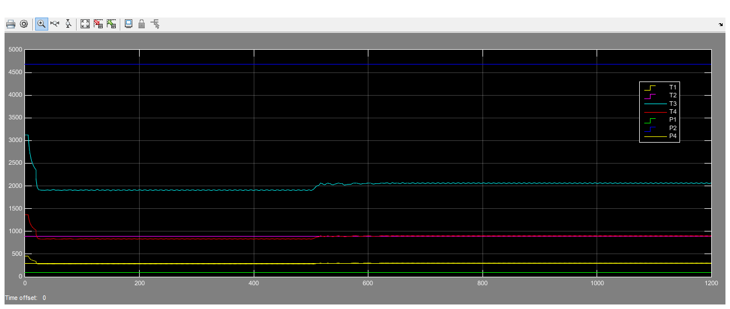

Thermal efficiency graph:

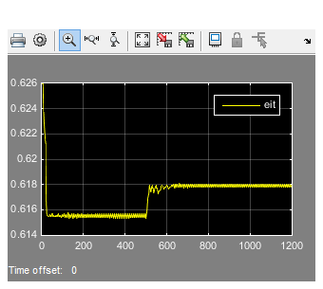

Engine speed, slip, selected gear, and ground velocity (24 shank wide open, 12” depth):

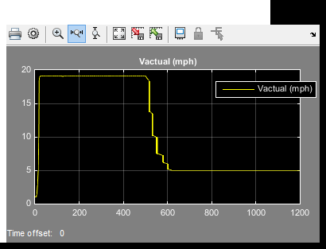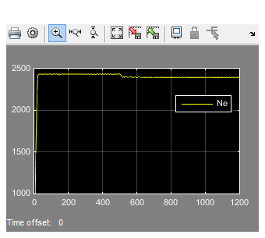

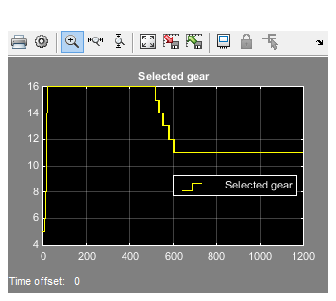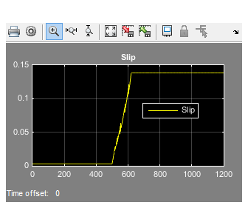

24 shank with depth of 24” with operator set speed at 10 km/h:

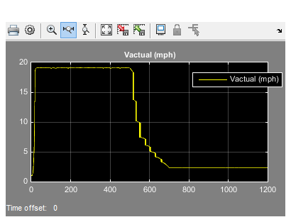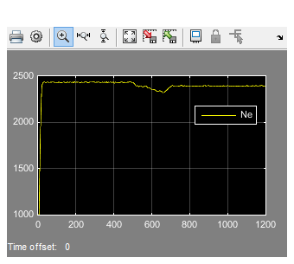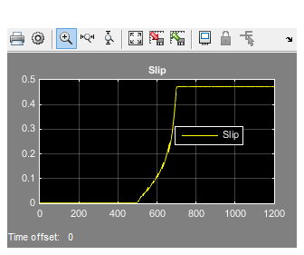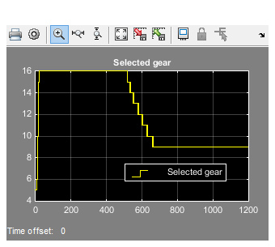

As these graphs show, there is still enough power available from the engine, but the amount of slip is very high. This makes sense when thinking about the tractor, which is a MFWD tractor (I modeled for rear wheel power only). I think it would be very interesting to build into this model the equations for engaging the front wheels to see if the engine could be overloaded, instead of the wheels running out of traction.

In conclusion, I found this project to be challenging and also very interesting. It truly is a summary of what we have covered throughout the year. Modeling after a real world tractor provides realism when many projects that we are tasked with are just numbers on a page. I was also able to pick a tractor, which was the Deere 8420. I picked this because it is a tractor that I have run for many years at our home farm, further adding to my interest in completing this project.